US ^{How To:}
UniqueSchools
Manage School Shop Refunds
Processing a refund to a parent/teacher who has made a payment through the App is very simple and straightforward. You can process a full refund or a partial refund of the item paid. Once processed the parent/teacher will receive a refund in 5-7 working days on the card with which they made the payment.
Please note you cannot refund “Cash Payments” received.
*PLEASE SEE IMPORTANT NOTE ON PAGE 3.
If you need any help please call the support team on 01 886 9458 or book a quick Zoom session with a member of the team.
Go to SCHOOL SHOP in your App CMS and select ORDERS.
You can find the order you need to refund using the filter/find options provided. This can be the actual order number, parents mobile number, student name etc. Input the details into the appropriate search field and press SEARCH. This will show a list of orders matching your search criteria. Select the order you need to refund.
Click the ‘eye’ icon under ‘View’.
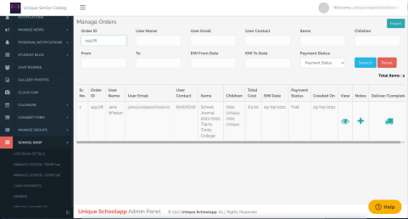next page
How To:
Access VSware from your App How To: Manage School Shop Refunds / 2
Select type of refund (FULL or PARTIAL)
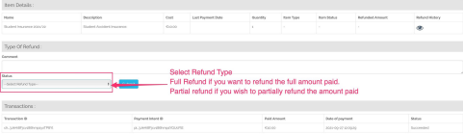FULL REFUND - select ‘Full Refund’ and ‘Submit’
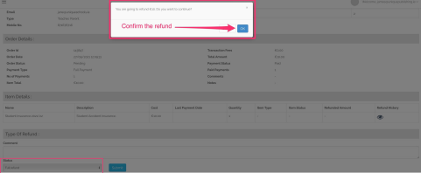
PARTIAL REFUND
- select ‘Partial Refund’
- select item to refund
- enter amount to be refunded
- enter reason why refund is being made and by whom so that you have a clear audit trail - press ‘Submit’
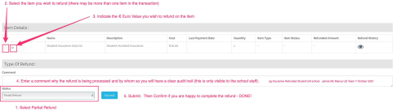
How To: Manage School Shop Refunds / 3
IMPORTANT NOTE ABOUT REFUNDS
The account infrastructure which US uses in Stripe for our school customers is that of a connected account attached to US Platform account. Your school connected Stripe account is designed to process receipts each day for immediate scheduled payout to your external bank account. No cash is held in this account and Stripe cannot reach into the Schools external bank account to cover a negative balance.
When a school process refunds to parents there is no “Cash Balance” in their Stripe Account to cover these refunds. As the Refunds are immediately processed through US CMS and the refund is accepted by Stripe an amount equivalent to the full amount of your refund is now “Held in Reserve” in the US Platform Account. This necessitates the US Platform account holding a significant cash balance to cover all school refunds, which we are happy to do. As future receipts are received into the schools Connected Account these are held to cover the value of the refunds processed and you will see these deducted in your Transaction History report.
When a school, or number of schools, process a large value in refunds which exceeds US normal Reserve balance maintained in Stripe a withdrawal is immediately taken, that same day, by Stripe from US external Bank Of Ireland Account to cover the refunds processed. With 100’s of schools using USPay this can reach a significant value very quickly and put undue pressure on US’s Bank.
For this reason we ask schools to notify US of all refunds in excess of €200 in a given week. If there are receipts expected into your Stripe Connected account we may not require a deposit from the school to cover the refunds, however if the value of the refunds is significant we will need the school to deposit an amount with US to cover these refunds before the school processes the refunds.

